SIMATS ENGINEERING (SAVEETHA SCHOOL OF ENGINEERING)
Department of Computer Science and Engineering
ASSESSMENT TOOL 2– Case Study (2 QUESTIONS)

Course Code: | ITA05 | Course Title: | COMPUTER VISION
CO Assessed: | CO3 – Precision (BL4) | Assessment: | Assessment Tool 1 – Case Study
Weightage: | 40% of CIA | Total Marks: | 20 (2 Questions × 10Marks)
CO1 Statement: | Analyze and extract image features using detection and matching techniques for effective image representation and comparison..(BL4)
Student Name: | Madhu Balan I | Reg. No.: | 192321142
Section / Batch: | B TECH IT | Date:
2
Code of Conduct
I _Madhu Balan I 192321142 (Name / Reg No) certify that this submission is my original work and that I have adhered to the guidelines specified for this assessment. I understand that any violation of academic integrity rules will result in disciplinary action.

Signature of the Student: _________________________

Instructions
- This test contains 2 questions, each carrying 10 marks. Total: 20 Marks.
- No negative marking. Unanswered questions carry zero marks.
- No calculators or electronic devices permitted.
- Duration: 60 minutes.

Section / Topic | Focus | Q Nos | Marks
Feature Detection and Matching | Preprocessing, Edge Detection, Harris Corner Detection, Hough Transform, SIFT | 1 | 10
Feature Detection and Matching | PCA, Image Representation, Feature Matching, Image Processing Applications | 2 | 10
GRAND TOTAL: |  | 20 Marks

Annexure A –Case Study

1.A remote sensing application is used to align satellite images of the same geographical region captured at different times for monitoring environmental changes. The system initially relies on edge detection to identify matching regions between the images; however, due to differences in illumination, image orientation, and background details, the matching process becomes unreliable and produces inaccurate alignment results. The development team decides to replace the edge-based approach with Harris Corner Detection to identify stable and distinctive feature points. Analyze the limitations of edge detection in this application and explain how Harris Corner Detection improves feature localization, matching accuracy, and robustness for image registration under varying imaging conditions.

2.An autonomous surveillance system continuously captures high-resolution color images to detect vehicles and pedestrians in real time. Processing the original color images directly increases computational complexity and slows down feature extraction, making it difficult to achieve the required processing speed. To improve system performance, the engineers consider converting the images into grayscale or binary representations before applying feature detection algorithms. Analyze the impact of different image representations on computational efficiency, edge detection, and feature extraction performance, and justify the most appropriate image representation for achieving accurate and reliable object detection in real-time computer vision applications.

CO3 – ASSESSMENT TOOL 2
CASE STUDY ANSWERS
Course: Computer Vision (ITA05)

QUESTION 1
Case: A remote-sensing system must align satellite images of the same geographical area captured at different times. The existing edge-based method is unreliable because of illumination, orientation, and background changes. The development team proposes Harris Corner Detection.

Answer
The main problem in this case is that edge detection does not provide sufficiently stable and distinctive points for satellite image registration. Edge detection identifies boundaries where image intensity changes sharply. In satellite images, these boundaries can change between different captures because of variations in illumination, shadows, vegetation, weather conditions, and background details. A road, building, or field boundary may therefore appear different in the two images. Changes in image orientation can also make direct edge-based correspondence unreliable. This results in incorrect matching of regions and inaccurate alignment of the two satellite images.

Limitations of Edge Detection
• It produces edges rather than distinctive points.
• Long edges may contain many possible matching locations.
• Illumination changes can alter the intensity transition and therefore the detected edges.
• Background changes can introduce additional or missing edges.
• Changes in orientation can make corresponding edges difficult to match.
• Edge information alone does not provide a strong description of the local region.
Therefore, although edges are useful for identifying object boundaries, they are less suitable as the primary features for reliable satellite-image registration in this situation.

How Harris Corner Detection Improves the System
Harris Corner Detection identifies points where image intensity changes significantly in two directions. These points are usually corners or highly distinctive local structures.
In a satellite image, suitable Harris features may occur at building corners, road intersections, field boundaries, and junctions of geographical structures.
Unlike a long edge, a corner provides a more localized and distinctive reference point. Therefore, the same geographical structure is more likely to produce corresponding corner points in images captured at different times.
The registration process can be represented as:
Satellite Image 1 → Harris Corner Detection → Stable Corner Points
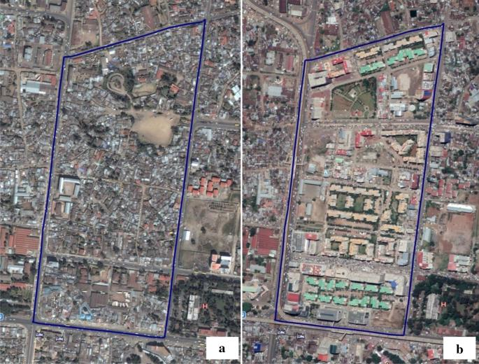
Satellite Image 2 → Harris Corner Detection → Corresponding Corner Points
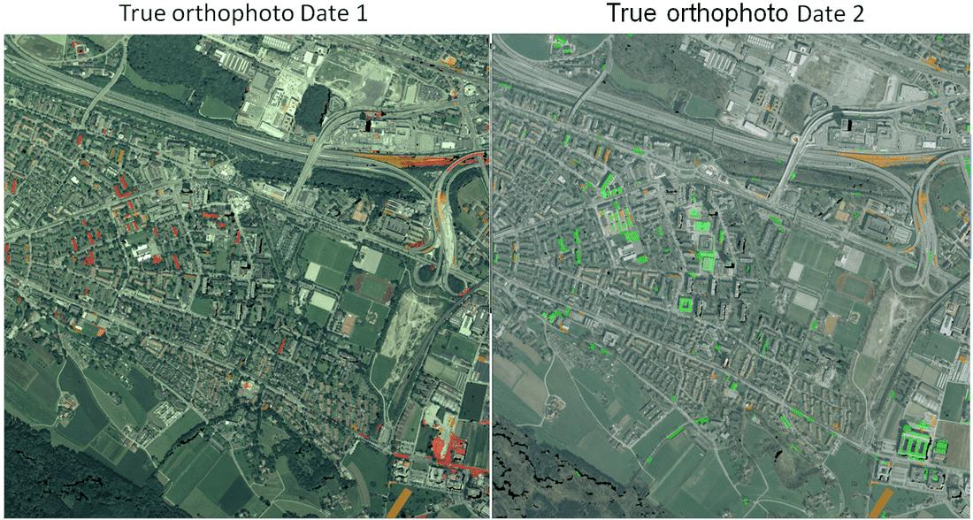
The corresponding corner points can then be used as reference points for image registration and alignment.

Improvement in Feature Localization
Harris provides precisely localized feature points rather than entire edge segments. This allows the registration system to identify specific corresponding locations between the two satellite images. For example, instead of matching a complete road boundary, the system can match a distinctive intersection or corner associated with that road.

Improvement in Matching Accuracy
Since Harris features are localized and distinctive, the probability of matching unrelated regions is reduced. Corresponding corner points can be compared between the two images and used as reference points for alignment. Thus, Harris can reduce the inaccurate matches produced by the original edge-based method.

Improvement in Robustness
The case specifically identifies illumination, orientation, and background variations as causes of failure. Harris corner detection provides more stable local points than raw edges, making the registration process more reliable under such changing image conditions.
However, Harris alone is not completely invariant to every possible scale or transformation. Therefore, for severe geometric changes, an additional feature descriptor could further improve robustness. This is an extension beyond the specific Harris-based solution proposed in the case.

Conclusion
For this remote-sensing application, replacing edge-based matching with Harris Corner Detection is a suitable improvement. Edge detection is highly affected by illumination, orientation, and background changes, whereas Harris provides localized and distinctive corner features that can be used to establish more reliable correspondences. Hence, Harris improves feature localization, matching accuracy, and the robustness of satellite-image registration under the conditions described in the case.

QUESTION 2
Case: An autonomous surveillance system captures high-resolution color images to detect vehicles and pedestrians in real time. Direct processing of color images increases computational complexity and slows feature extraction. The engineers consider grayscale or binary representations.

Answer
The main challenge in this case is to achieve real-time vehicle and pedestrian detection while maintaining sufficient image information for accurate feature extraction.
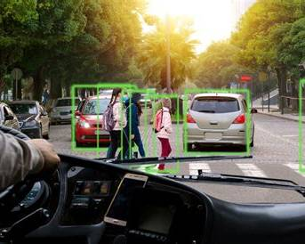
Processing the original high-resolution color image is computationally expensive because a color image normally contains multiple channels. Every stage of the vision pipeline, including preprocessing, edge detection, and feature extraction, must process this additional information. As a result, processing time increases and the required real-time performance becomes difficult to achieve.

Color Representation
The original color image contains the maximum visual information, including intensity and color information. This can be useful when object color is an important distinguishing feature.
However, for the stated surveillance problem, directly processing high-resolution color images increases computational complexity. This directly causes the feature-extraction process to slow down, which is undesirable for real-time detection.
Therefore, although color contains more information, it is not the most efficient representation for the particular real-time requirement.

Grayscale Representation
A grayscale image represents the scene using intensity rather than separate color channels. This reduces the amount of image data that must be processed while preserving important structural information such as object boundaries, shapes, intensity changes, edges, and local features.
This is particularly useful because many feature-detection techniques rely primarily on intensity variations and geometric structures, rather than color itself.
For vehicle and pedestrian detection, grayscale can therefore reduce computational complexity while retaining the important information required for edge detection and feature extraction.

Binary Representation
A binary image contains only two intensity values, normally representing foreground and background. This representation is computationally very efficient because there are only two possible pixel values.
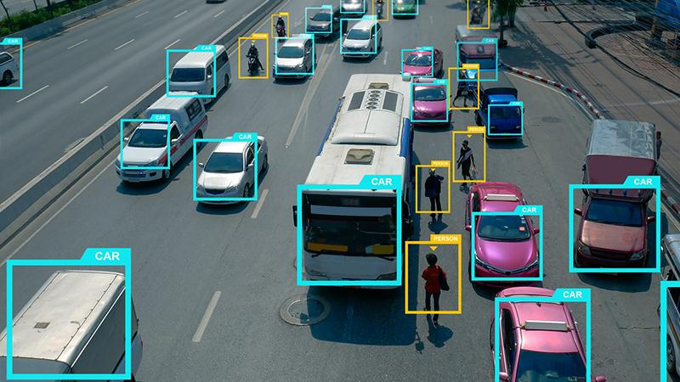
It can be useful when segmentation has already separated the objects from the background. However, binary conversion removes much of the original intensity information. Fine details and gradual intensity changes can be lost. Consequently, important characteristics of vehicles and pedestrians may disappear, especially when the scene contains shadows, overlapping objects, or complex backgrounds.
Therefore, binary representation may be too restrictive as the primary representation for reliable feature extraction in this surveillance system.

Comparison
Representation | Computational Cost | Information Preserved | Feature Extraction
Color | High | Highest | Good but slower
Grayscale | Lower | Important structural information | Good
Binary | Very low | Limited | Can lose useful details

Most Appropriate Representation
For the case described, grayscale is the most appropriate image representation. The reason is that the surveillance system must satisfy two requirements simultaneously: high processing speed and accurate and reliable object detection.
Grayscale reduces computational complexity compared with the original color image while retaining the intensity and structural information needed for edge detection and feature extraction. Binary images are faster still, but the loss of image information can reduce detection reliability.
Therefore, the practical workflow is:
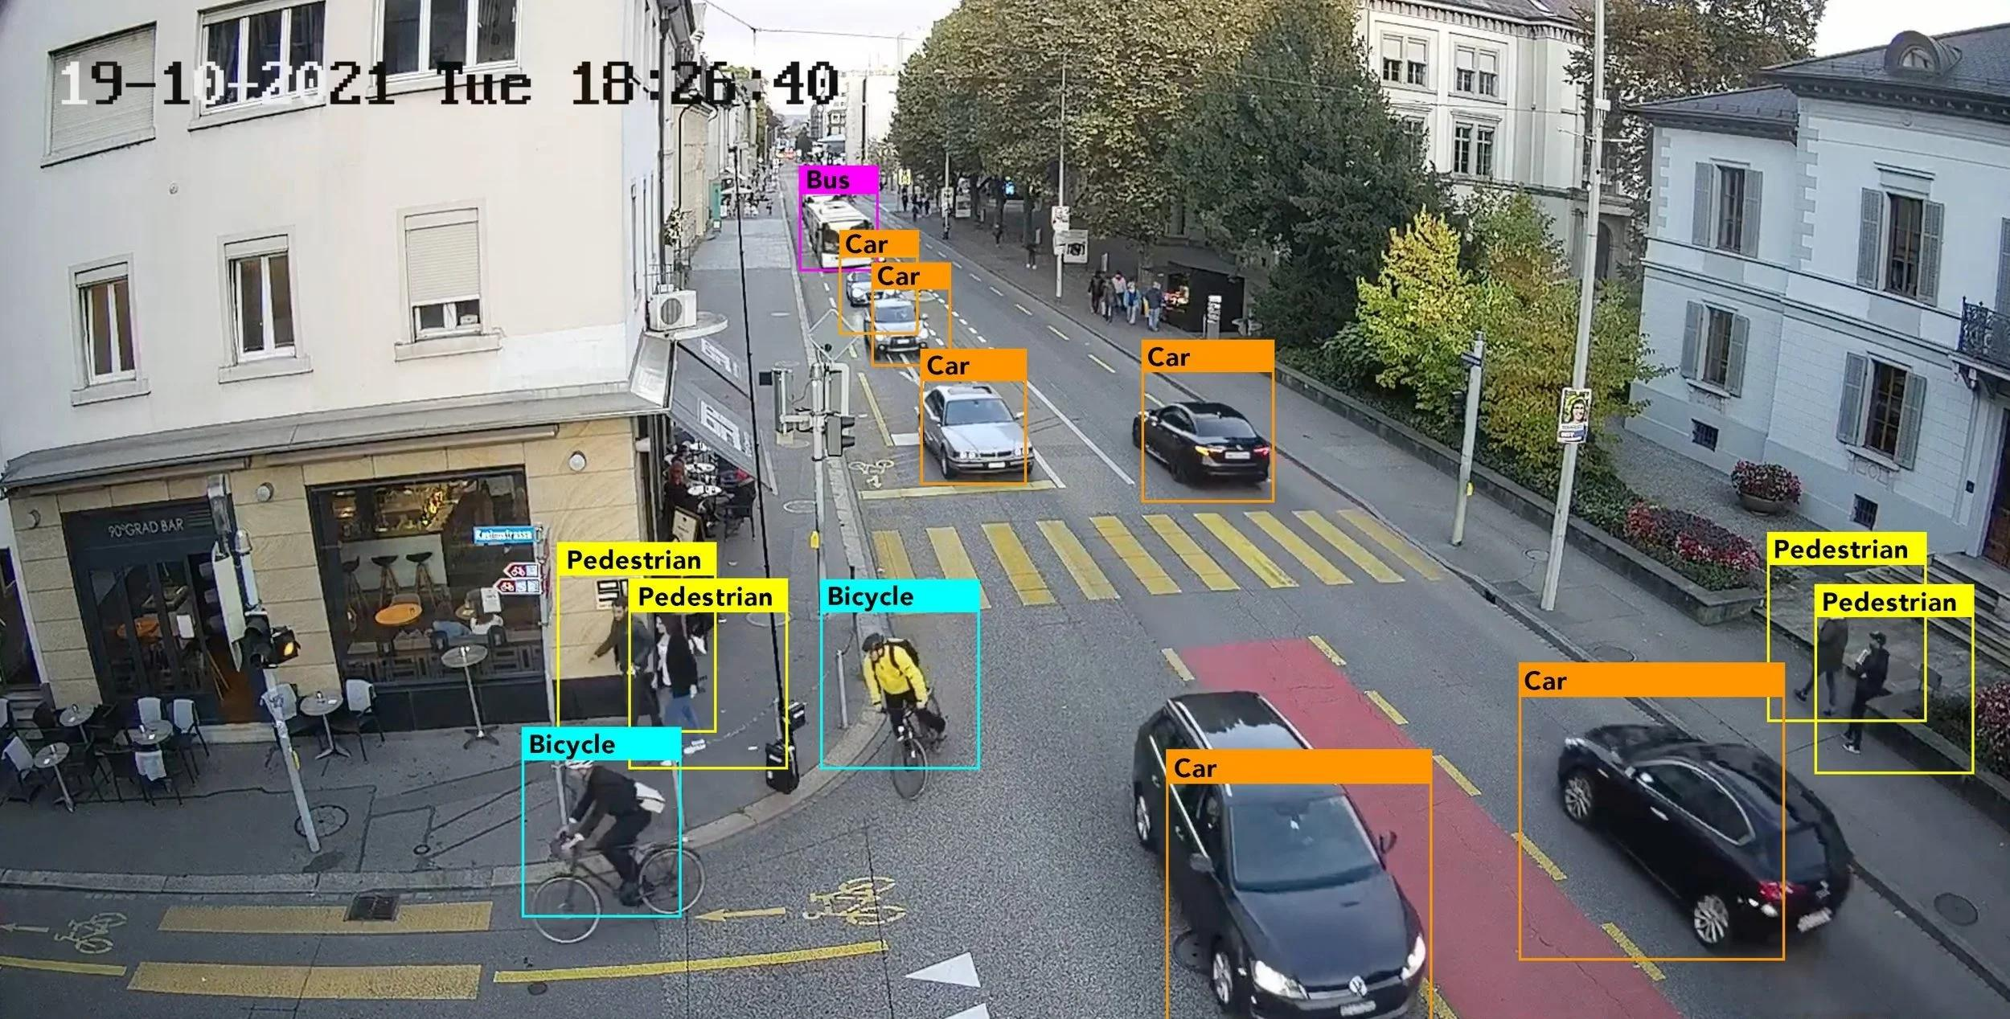

High-Resolution Color Image → Grayscale Conversion → Feature Detection → Vehicle/Pedestrian Detection

Conclusion
For the autonomous surveillance case, converting the high-resolution color images to grayscale before feature detection provides the best balance between processing efficiency and detection accuracy. Color processing is computationally expensive, while binary representation can remove useful details. Grayscale reduces the computational burden while preserving the structural information required for reliable real-time vehicle and pedestrian detection.

Rubrics for Calculation

Criteria | Weightage | Level 4 – Exemplary | Level 3 – Proficient | Level 2 – Developing | Level 1 – Beginning | Marks
Understanding of Case | 25 | Thorough understanding; clearly identifies all key issues | Good understanding with most issues identified | Basic understanding; some issues missed | Poor understanding; problem not identified correctly
Application of Concepts | 25 | Effectively applies relevant concepts to analyze the case deeply | Applies appropriate concepts with minor gaps | Limited application of concepts | Fails to apply relevant concepts
Analysis | 20 | In-depth analysis with strong reasoning and insights | Good analysis with logical reasoning | Basic analysis with limited depth | Weak or no analysis; lacks reasoning
Solution Design | 20 | Innovative, feasible solutions with strong justification | Logical solutions with adequate justification | Basic solutions with weak justification | Incorrect or no solution provided
Clarity | 10 | Clear, well-structured, and easy to understand | Organized and understandable presentation | Limited clarity and structure | Poor clarity; difficult to understand

Faculty In-charge
Signature: _______________
Date: ___________________

